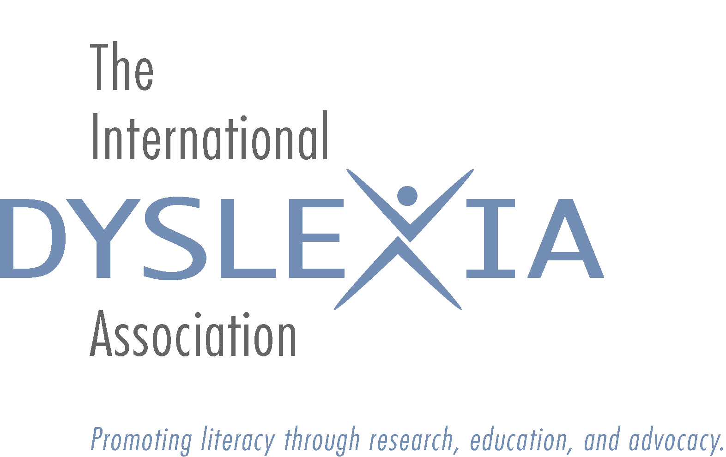
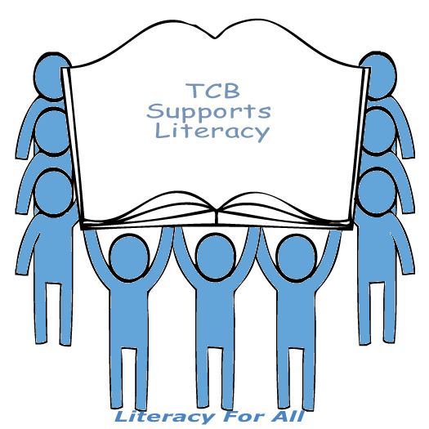
Southern CA Tri-Counties Branch
Formerly Inland Empire Branch IDA
5225 Canyon Crest Drive, #71-308
Riverside CA 92507
tcb.info@dyslexia-ca.org
www.dyslexia-ca.org

SCHOLARSHIP APPLICATION FOR LOCAL TCB CONFERENCE / WORKSHOP
Parents and Teachers

Scholarships awarded will be in the amount of $50 and will be presented as a rebate check or as a deduction of conference fees.

First Name | Last Name | Email
Address |  | City State Zip
Home phone | Work phone | Cell phone
IDA Membership # | School District | Job title
IDA Branch | If parent, ages of your children | LD in your family?
If teacher, years taught | Grade(s) | Credentials

You may obtain your membership # and other membership information by emailing tcb.info@dyslexia-ca.org
Criteria:

- Scholarship recipient must be a current member of IDA
- Recipient must be a current resident, employed in, or registered as a student in the geographic area serviced by the Tri-Counties Branch (Orange, Riverside, & San Bernardino Counties, and San Gabriel).
- Recipient agrees to perform a PR task for the Branch, within one month of event. Select one:
  - Write an article about the usefulness of the conference or workshop for the branch newsletter
  - Contact a local newspaper and have them print an interview about his/her experience at the event
  - Speak at a specific local service group (i.e., Rotary) for fund raising purposes (verification required)

Application information (please respond on additional sheet of paper):
- Explain your reason(s) for wishing to attend this conference.
- Explain how you will use the information, techniques and strategies learned.
- Explain your motivation for working with learning-disabled children or adults OR explain your motivation for learning more about learning-disabled children.

Application Submitted by:_________________________________________________________

Date:_____________________________

Scholarship deadline – NO EXCEPTIONS: Completed and signed application must be received no later than 14 days prior to the event

Send application to The So. CA Tri-Counties Branch at the address above
Or email to tcb.info@dyslexia-ca.org

